Search Machine in Industry 4.0

# Setup Instruction:

## Windows:

1. Download and install [MongoDb](https://www.mongodb.com/).
2. Make sure to add MongoDb to system variables.

### How to add system variable:

#### Windows 10 and Windows 8:

1. In Search, search for and then select: System (Control Panel)
2. Click the Advanced system settings link.
3. Click Environment Variables. In the section System Variables, find the PATH environment variable and select it. Click Edit. If the PATH environment variable does not exist, click New.
4. In the Edit System Variable (or New System Variable) window, specify the value of the PATH environment variable(For Default install folder it will be – “C:\Program Files\MongoDB\Server\3.6\bin”). Click OK. Close all remaining windows by clicking OK.

#### Windows 7:

1. From the desktop, right click the Computer icon.
2. Choose Properties from the context menu.
3. Click the Advanced system settings link.
4. Click Environment Variables. In the section System Variables, find the PATH environment variable and select it. Click Edit. If the PATH environment variable does not exist, click New.
5. In the Edit System Variable (or New System Variable) window, specify the value of the PATH environment variable(For Default install folder it will be – “C:\Program Files\MongoDB\Server\3.6\bin”). Click OK. Close all remaining windows by clicking OK.
6. MongoDB’s default data directory path is the absolute path \data\db on the drive from which you start MongoDB. Create this folder. For default installation create \data\db in C drive.
7. Now MongoDb is ready to use. Open Command Prompt and execute “mongod”.
8. Download and Install [Node.js](https://nodejs.org/en/download/) for your Operating System.
9. Make sure to add node.js to system variables.

## Linux:

1. Download and install [MongoDb](https://docs.mongodb.com/manual/tutorial/install-mongodb-on-ubuntu/).
2. Now open terminal and issue following command “sudo service mongod start” to start mongod.
3. Download and Install [Node.js](https://nodejs.org/en/download/) for your Operating System.
4. Make sure to add node.js to system variables.

# Setup Database and collection:

1. If your previously have database named “Industry_4_0” then it will use this database. Otherwise it will create a database named “Industry_4_0”.
2. If your “Industry_4_0” database have collections “machine_types” and “details” then it will use these collections. Otherwise It will create these two collection.

# Clone the Repository:

1. Clone and Download this Repository and unzip.

# Running the Web server

1. Open Terminal and Navigate to ~/website/search/bin/
2. Run npm install
3. Run node www

# Use Search:

1. Navigate to http://localhost:3000/ in browser
2. This will open following webpage-

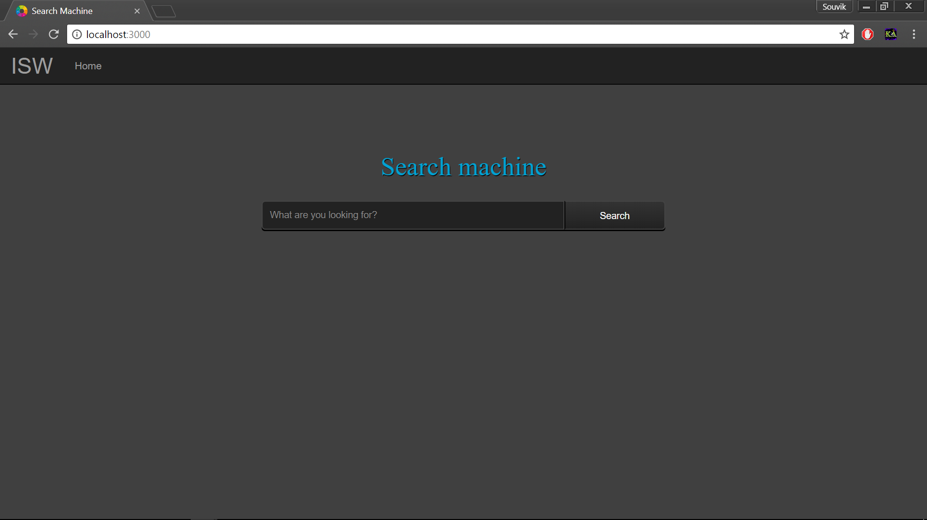

1. Enter whatever you want to search in the input field. For reference-

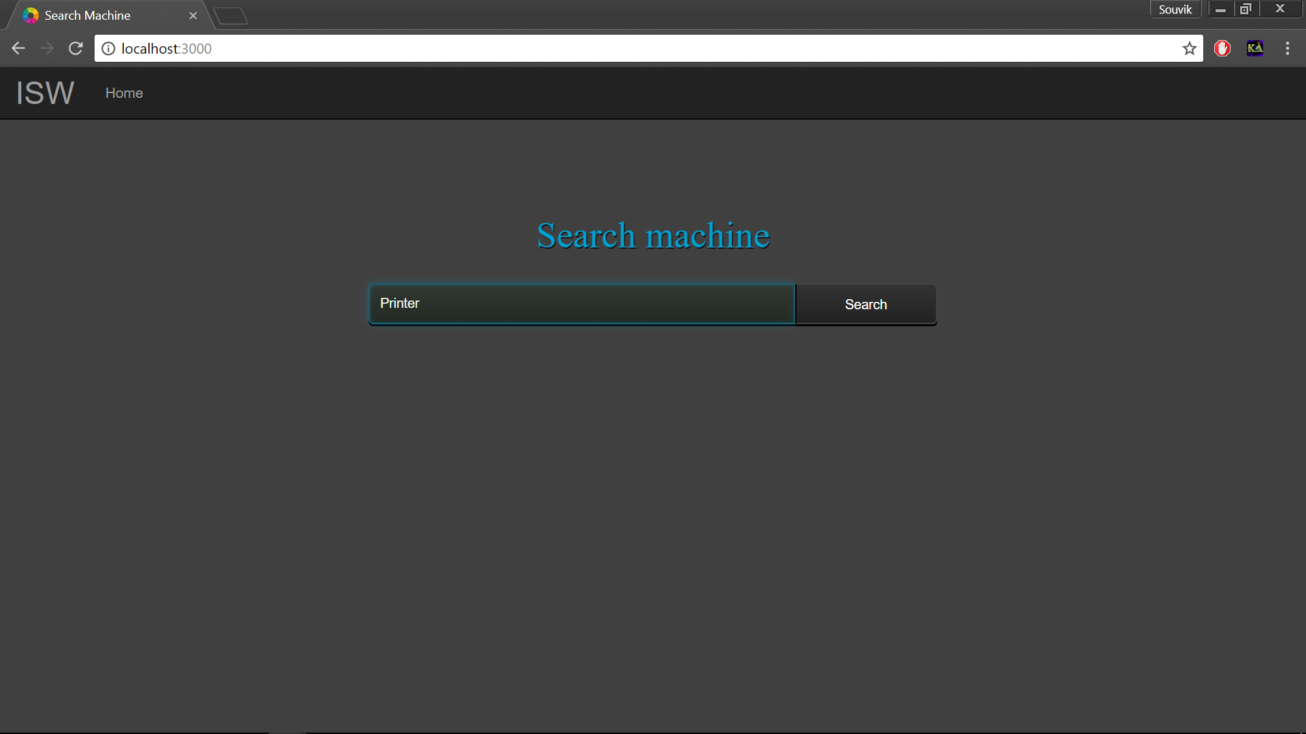

1. Press enter key in keyboard or hit search button in webpage. It will show you results related to entered value.

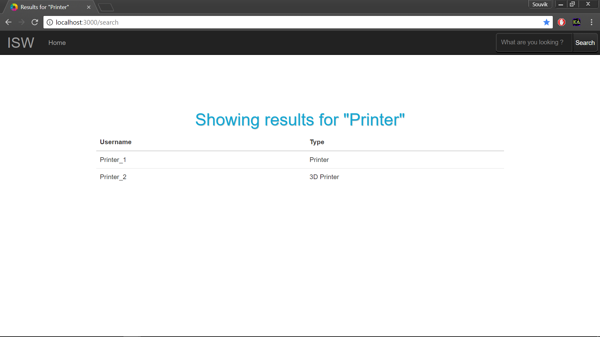

1. On clicking any result it will take you to details page showing details about that machine.
2. If nothing is similar to entered key in database then following page will show up –

